Assessment Brief
*This document is for CU Group students for their own use in completing their assessed work for this module and should not be passed to third parties or posted on any website. Any infringements of this rule should be reported to engagement@coventry.ac.uk
Module Title: Control of Mechatronic Systems
Module Code: 209EN

Task:
The mass-spring-damp system shown in Fig. 1 represents a restorer device for the element of mass m – on which the mass of the system is concentrated – whenever the car, whose mass is negligible, suffers a displacement. For this system, u(t) is the displacement of the car and is the input variable. The mass displacement, y(t) is the output. Both displacements are measured relative to the ground. For m = 500 kg, k = 245 N/m and c = 90 N.s/m:

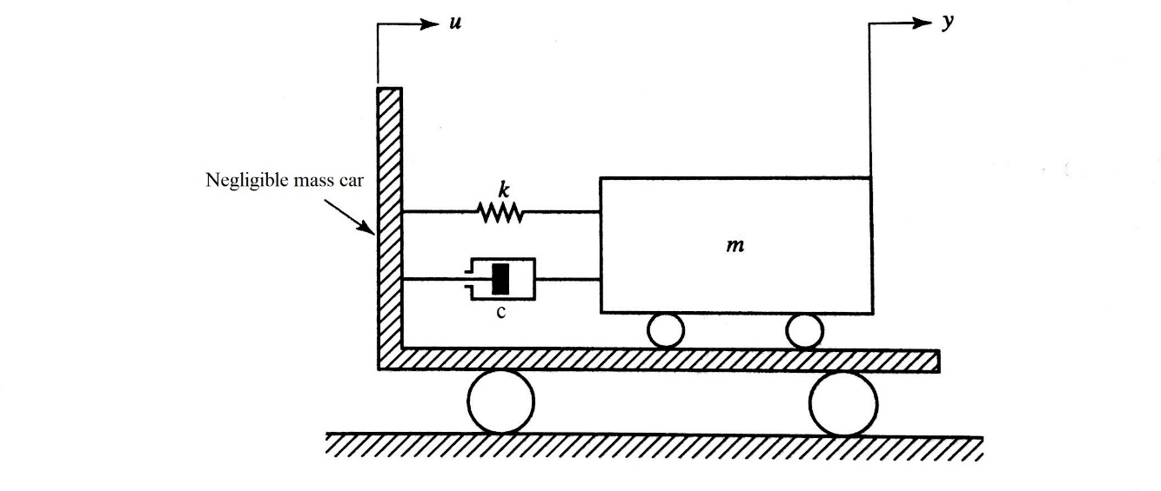
Figure 1 – Restoring system for the mass under transportation in a car.

- DETERMINE the open-loop transfer function for the given system

Free body diagram of the system
y
K$\left(y-u\right)$
m
$C\left(y-u\right)$

C= 90
K= 245
M=500
Equation of motion
My + c(y-u) + k (y-u) = 0
My+ cy-cu+ky = cu + ku
Applying laplace trean & forem
Ms²y + csy + kY = csu + ku
( ms²+ cs + k)y = (cs + k)u
G(s) = $\frac{cs+k}{ms^{2}+cs+k}$= $\frac{Y(s)}{u(s)}$
G(s) = $\frac{90s+245}{500s^{2}+90s+245}$ = $\frac{Y(s)}{u(s)}$
Y(s)= $\frac{90s+245}{500s^{2}+90s+245}$ x u(s)
U(t)= 3000
V(s) = $\frac{3}{5}$
Y(s)= $\frac{3(90s+245)}{5(500s^{2}+90s+245)}$ = $\frac{270s+735}{5( 500s^{2}+90s+245)}$

- PLOT the response of the open-loop system when the car is displaced, from rest, by 3 m.

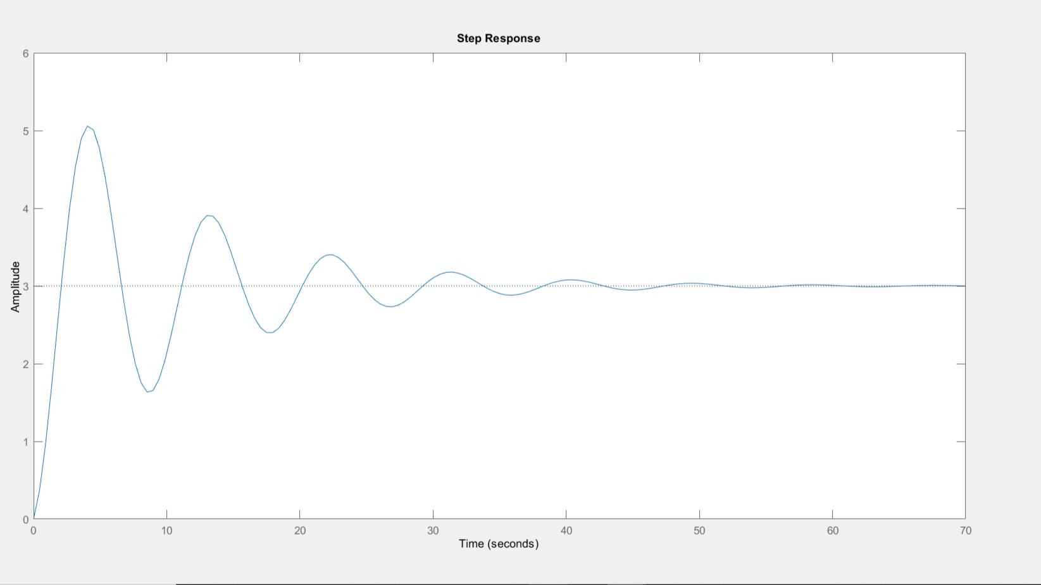

- DESIGN the closed-loop system by fitting a PID controller to the plant.
To design PID controller for the plant, we obtain an open-loop response and determine what need to be improved. Then add a proportional control to improve the rise time. Add a derivative control to reduce the overshoot and an integral control to reduce the steady state of error. Lastly, adjust each of the gains (proportional, derivative, and integral) until you obtain a desired overall response.

- PLOT the response of the controlled system when the car is moving with a constant velocity $\dot{u}=1.5 m/s$, but no tuning of the controller has taken place yet.
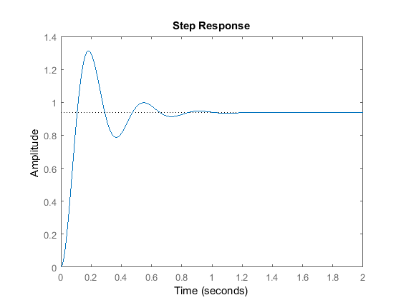

- Using the closed-loop Ziegler-Nichols method, ADJUST the PID controller performance. If this method cannot be used, fine-tune the PID by an alternative procedure.
The method is not applicable, thus opted to use Automatic PID Tuning.

VI) PLOT the response of the controlled system with a tuned controller for the same conditions of IV. Compare both plots and CALCULATE the percentage reduction in the maximum overshoot and in the transient time.
MATLAB provides tools for automatically choosing optimal PID gains which makes the trial and error process. The MATLAB automated tuning algorithm chooses PID gains to balance performance (response time, bandwidth) and robustness (stability margins).
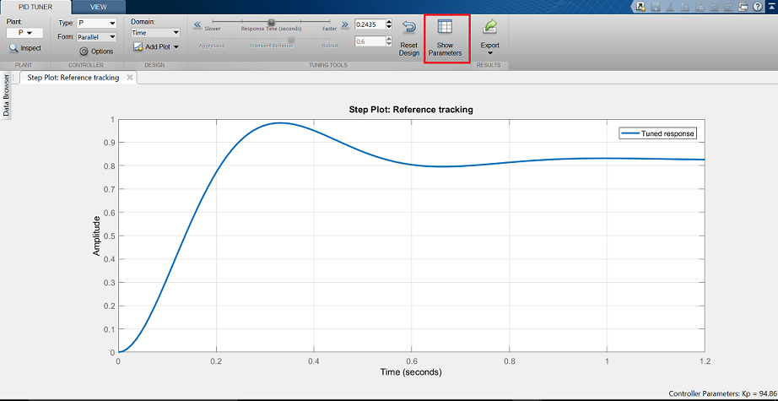

You are required to prepare a technical report with the above analysis. Also, you are required to use LabVIEW for the numerical simulations.

